The p-orbital is __________ shaped.
A. Spherical
B. Dumb-bell
C. Cloverleaf
D. Elongated dumbbell
ANSWER: B
In the nodal plane, the probability of finding an electron is __________.
A. Multiple integral
B. Minimum
C. Maximum
D. Zero
ANSWER: D
The degenerate p-orbital are __________ to each other.
A. Perpendicular
B. Parallel
C. Similar
D. None of the above
ANSWER: A
Number of lobes in the fifth d- orbital are
() Four
() Eight
(x) Two
() three
ANSWER: C
Size of 2s-orbital as compared to 1s-orbital is
(x) large
() small
() very large
() none
ANSWER: A
Size of S-orbital increases when the value of principle quantum number is
() decrease
(x) Increase
() remain same
() none
ANSWER: B
Which orbital possess this shape?
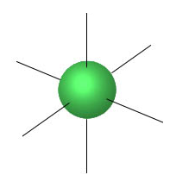
A. s
B. p
C. d
D. f
ANSWER: A
Which orbital possess this shape?
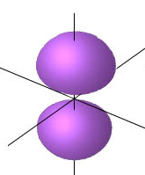
A. $s$
B. $p_{x}$
C. $p_{z}$
D. $p_{y}$
ANSWER:
Which orbital possess this shape?
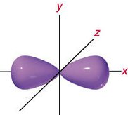
A. $s$
B. $p_{x}$
C. $p_{z}$
D. $p_{y}$
ANSWER: B
Which orbital possess this shape?

A. $s$
B. $p_{x}$
C. $p_{z}$
D. $p_{y}$
ANSWER: D
Which orbital possess this shape?
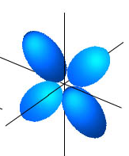
A. s
B. p
C. d
D. f
ANSWER: C
How many nodal planes are present in 1s,2s, and 3s orbital?
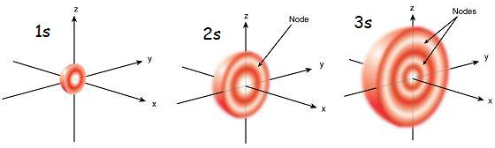
A. 1, 2, 3
B. 0, 1, 2
C. 1, 1, 2
D. 2, 1, 0
ANSWER: B
Four types of orbitals depend upon the values of
A. Principal Quantum Number
B. Azimuthal Quantum Number
C. Magnetic Quantum Number
D. Spin Quantum Number
ANSWER: B
Which of the following contain four lobes?
A. $s$
B. $p_{x}$
C. $d_{xy}$
D. All of these
ANSWER: C
Which of the following is incorrect for d-orbitals?
A. Five d orbitals are degenerate in the presence of magnetic field
B. First three d-orbitals lie between the axis
C. $d_{x^{2}-y^{2}}$ and $d_{y^{2}}$lie on the axis
D. None of these
ANSWER: D

